EXP 12: CHANGE HARDWARE COMPATIBILITY OF A VM (EITHER BY CLONE/CREATE NEW ONE) WHICH IS ALREADY CREATED AND CONFIGURED.
AIM: To Change Hardware compatibility of a VM (Either by clone/create new one) which is already created and configured.
PROCEDURE:
step 1: goto vm ware workstation.
step2: right click the vm and goto the settings.
step 3: add hardware wizard and select scsi and click next.
step 4: create new virtual disk.
step 5: select the disk size as 2.0. and select split virtual disk into multifiles.
step 6: give name and click the finish.
IMPLEMENTATION:
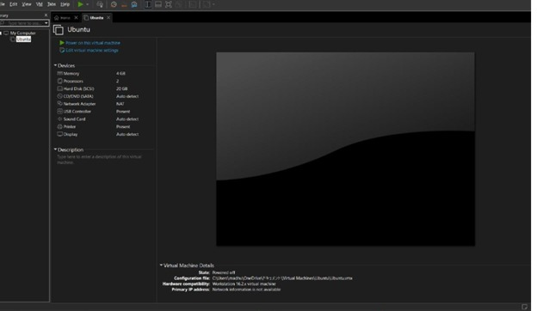

RESULT: thus,it was successfully completed

